E-SPIR Supplier 8.60 — Installation & Setup Guide
Version 8.60.00002| Shell Equipment Spare Parts Interchangeability Records
Before You Begin
- Installer file: ESPIRSupplierSetup.msi
- Database file: E_SPIR_SSQL.db (SQLite)
- OS: Windows 10 / 11 (64-bit recommended)
- .NET Framework: Ensure the required .NET Framework version is installed

- Download the .Zip file and extract I to the local machine
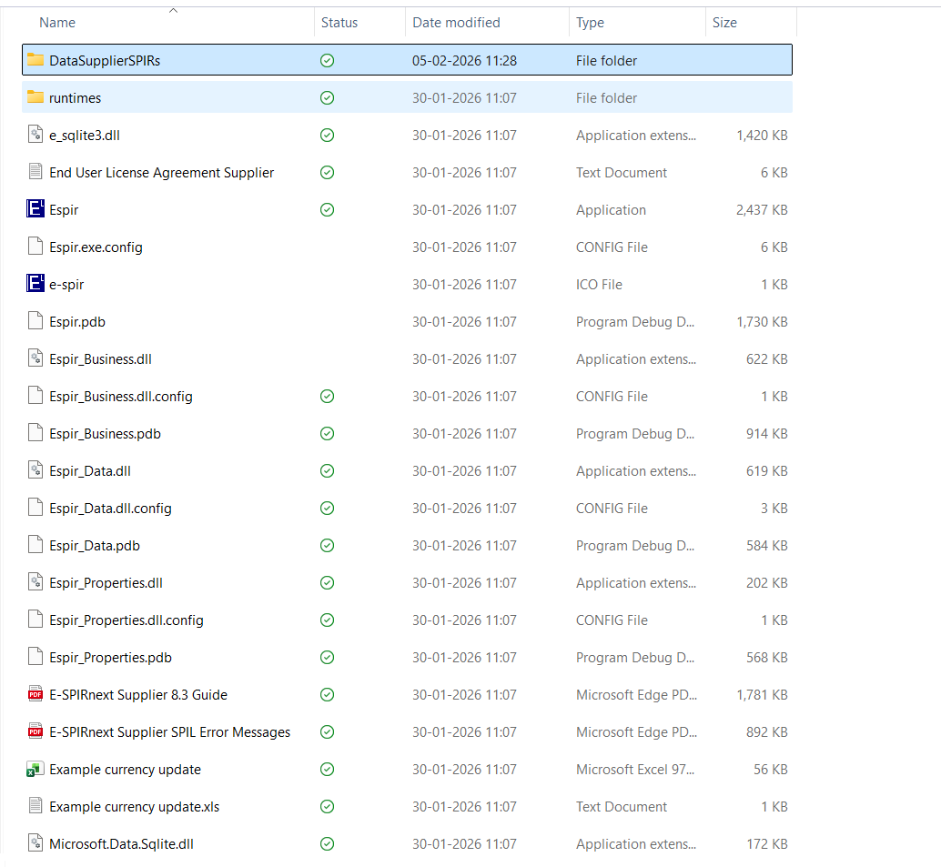
- Open the Extracted folder

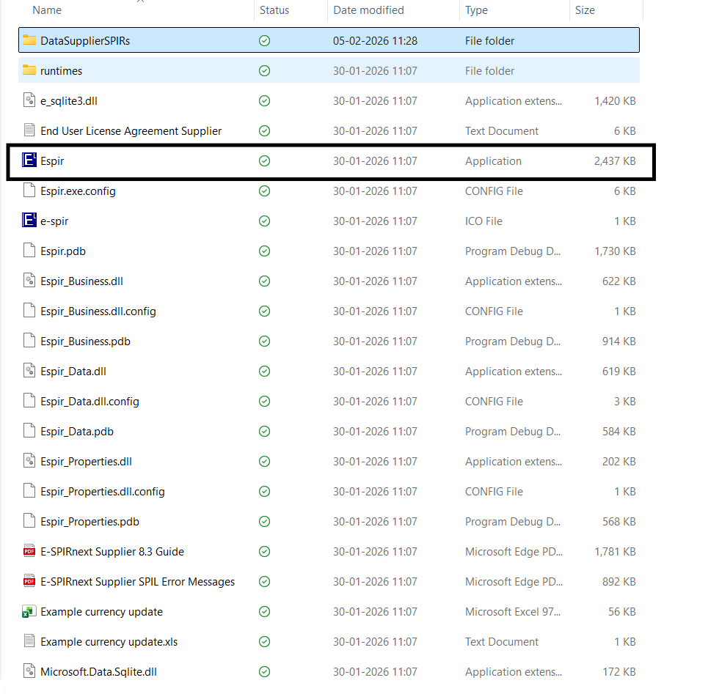
- Open the Espir.exe file

- Right-click Espir.exe > Properties > check "Unblock" at the bottom > OK

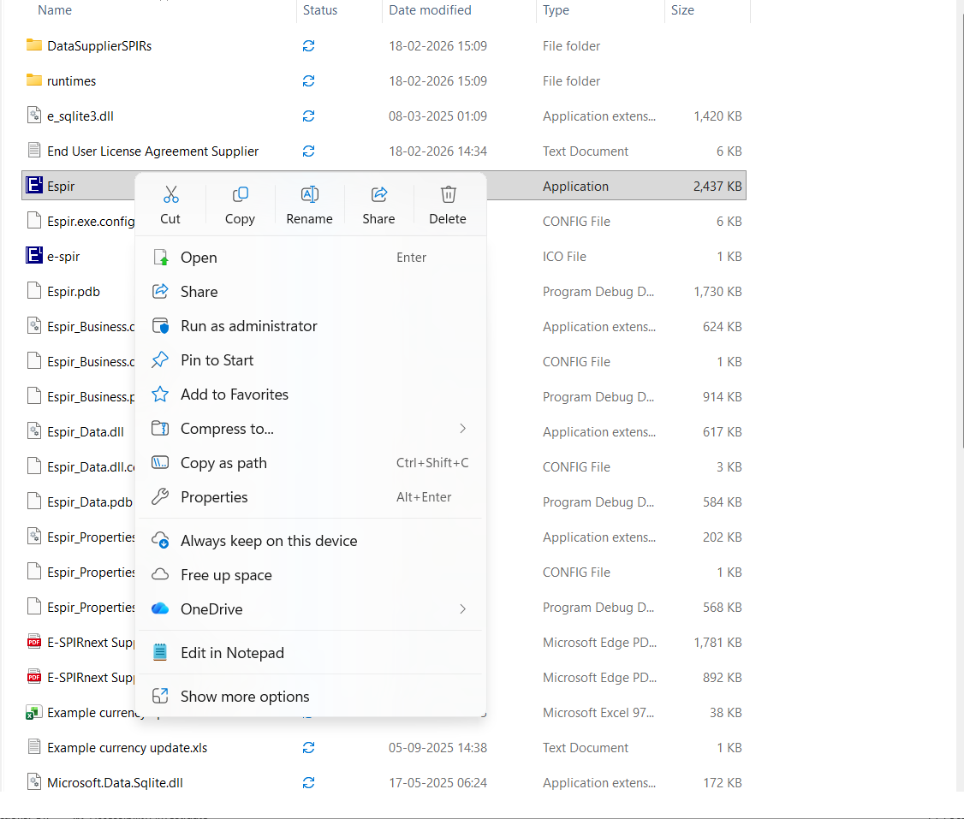

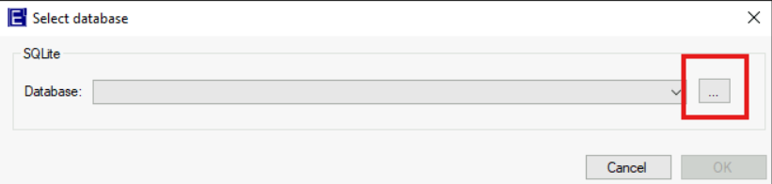
- A Select Database Dialog box will appear. Click the … (browse) button in the Select database dialog. click Open.

- Navigate to Extracted file folder-> DataSupplierSPIRs - select the Database file
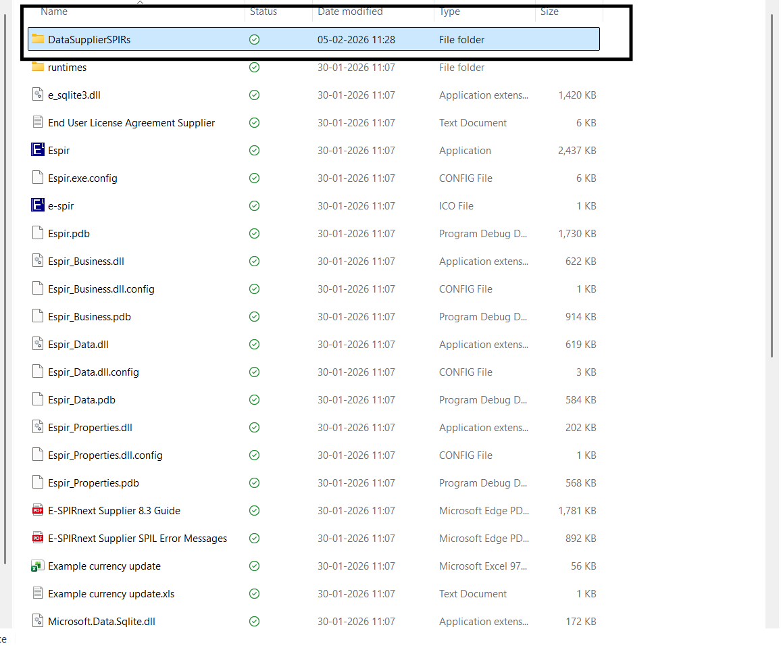
- Once the database file is selected, click OK to connect to the database and load the application data.

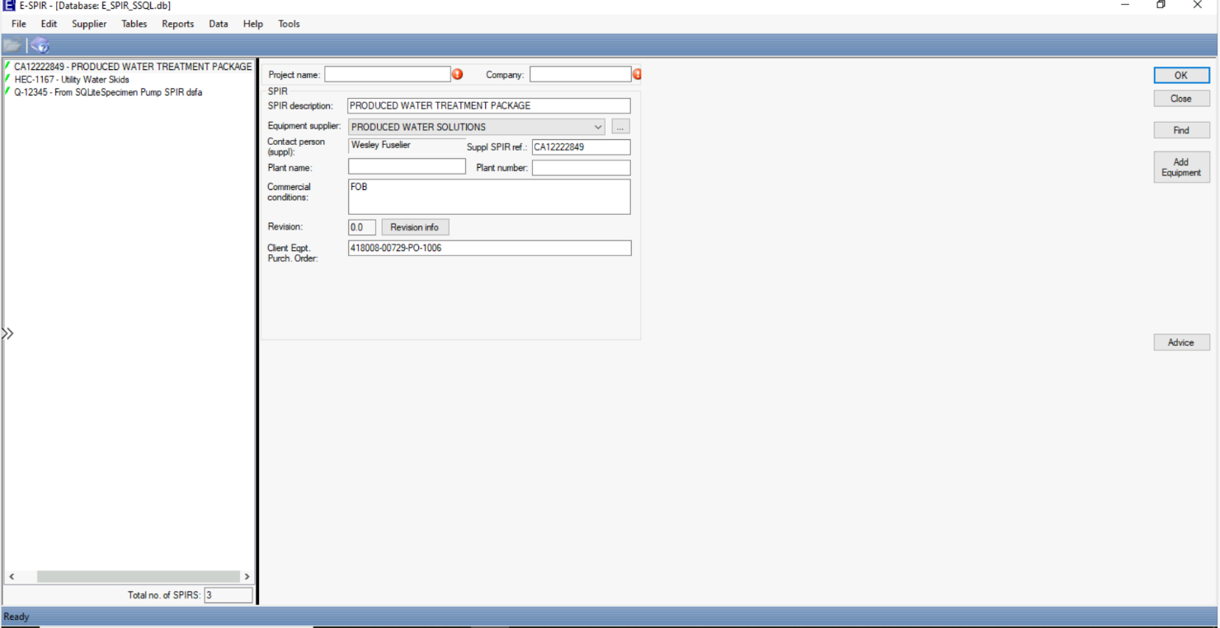
- The E-SPIR application will open displaying the SPIR records from the database. You can now browse SPIRs, manage equipment, view spare parts data, and perform all supplier operations.

