E-SPIR Supplier 8.60 — Installation & Setup Guide
Version 8.60.00002| Shell Equipment Spare Parts Interchangeability Records
Before You Begin
- Installer file: ESPIRSupplierSetup.msi
- Database file: E_SPIR_SSQL.db (SQLite)
- OS: Windows 10 / 11 (64-bit recommended)
- .NET Framework: Ensure the required .NET Framework version is installed
- Permissions: Administrator rights may be needed for installation

- Locate the ESPIRSupplierSetup.msi installer on your desktop or designated folder and double-click to launch the Setup Wizard. The Welcome screen for E-SPIR Supplier 8.60.00020 will appear.
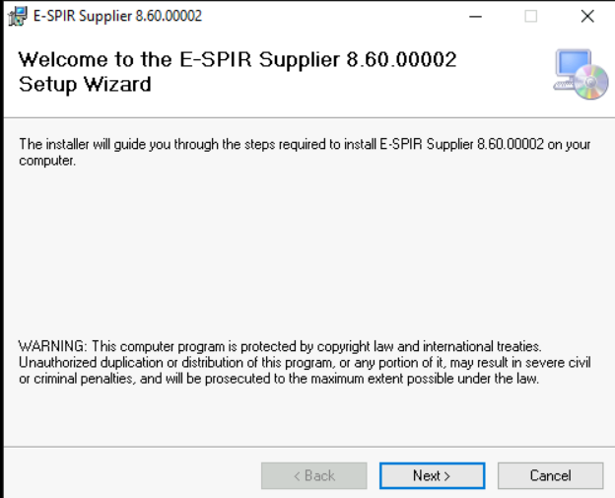

- On the Welcome screen, click the Next > button to continue to the installation folder selection screen.
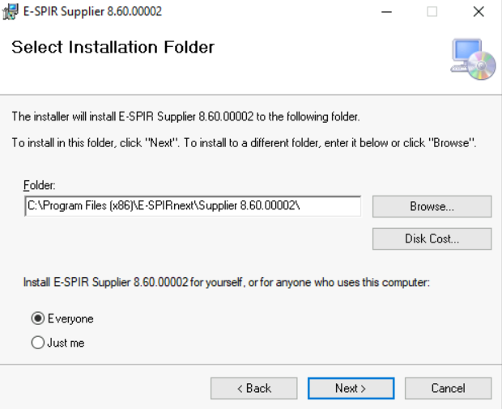

- The default installation path is:
C:\Program Files (x86)\E-SPIRnext\Supplier 8.60.00020\

You can change the destination by clicking Browse…. Select whether the application should be available for Everyone or Just me, then click Next >.

- Review the installation summary. When you are ready, click Next > to begin copying files to your system.
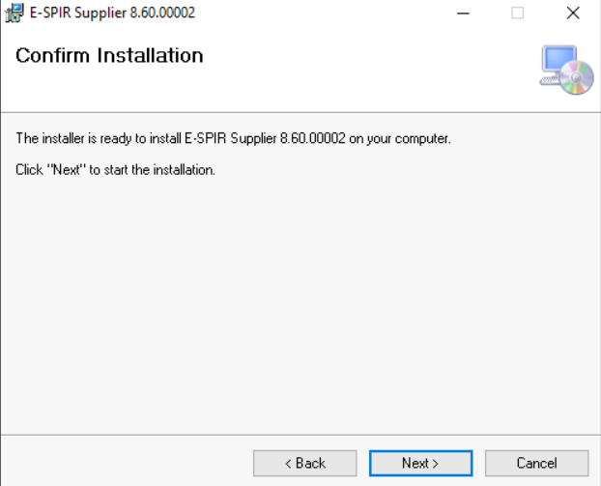

- Once the installer finishes, you will see the Installation Complete screen. Click Close to exit the wizard.

- After installation, the E-SPIR Supplier 8.60.00020 application shortcut and the E_SPIR_SSQL.db database file will be visible on your desktop.
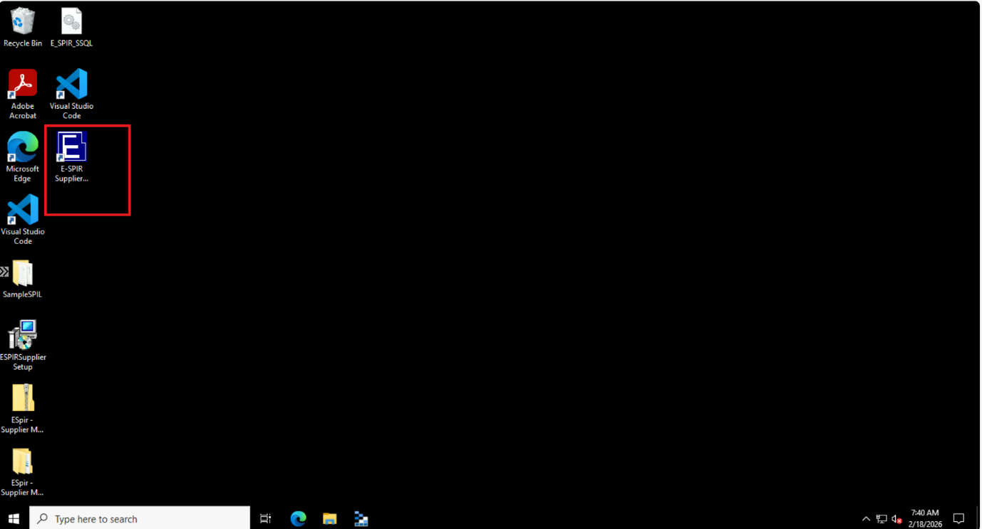

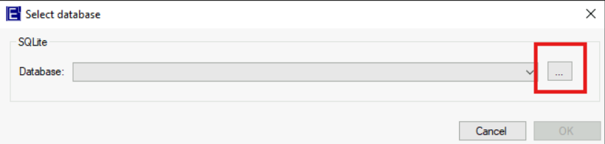
- Double-click the E-SPIR Supplier 8.60.00020 shortcut on the desktop to launch the application. A Select database dialog will appear.

- Click the … (browse) button in the Select database dialog. Navigate to your Desktop and select the E_SPIR_SSQL.db file, then click Open.

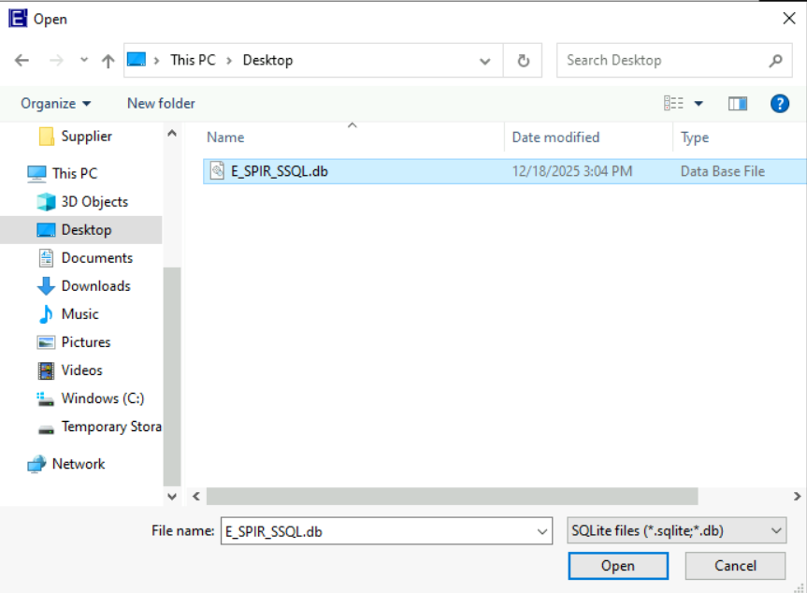

- Once the database file is selected, click OK to connect to the database and load the application data.

- The E-SPIR application will open displaying the SPIR records from the database. You can now browse SPIRs, manage equipment, view spare parts data, and perform all supplier operations.
